DATA VALIDATION SYSTEM
Java Swing Application
Documentation Report
Student Name | Khensani Mathye
Year of Study | Second Year
Course | System Development
College | Gauteng City College
Lecturer | Mr Owami
Assignment | Data Validation System — Java Swing
Date | 22 September 2026

Table of Contents
1. Introduction 3
2. System Design 3
3. Fields 4
4. Validation Checks 4
5. Testing 5
6. Code Walkthrough 6
7. GitHub Repository 7
8. Conclusion 7
9. References 7

1. Introduction
The Data Validation System is a desktop application developed using Java Swing. Its purpose is to capture personal information through a graphical user interface and validate the information before it is accepted. The system provides clear feedback when information is missing or does not meet the required rules.
The assignment requires the application to demonstrate presence, type, length, format and range checks where appropriate. The interface is also expected to provide a clean layout, clear labels, sensible spacing, a logical workflow and user-friendly validation messages.

2. System Design
The system was planned around a simple form layout so that users can enter their information in a logical order. Labels are placed next to their corresponding input components, and validation messages can be displayed close to the relevant field. Gender is captured using radio buttons so that the user can select one option.
The design focuses on readability and ease of use. The Save action is intended to validate the entered information, Clear removes the entered information so the form can be reused, and Exit closes the application. Error messages are written in a simple way so that an ordinary user can understand what needs to be corrected.

3. Fields
The form contains the required personal-information fields specified in the assignment brief.
Field | Purpose
Name and Surname | Captures the user's full name.
ID / Student Number | Captures a unique identification or student number.
Date of Birth / Age | Captures the user's date of birth or age, depending on the implemented form.
Gender | Allows the user to select a gender option using radio buttons.
Contact Number | Captures the user's telephone/contact number.
Email Address | Captures the user's email address for contact purposes.

4. Validation Checks
Validation is used to prevent incorrect or incomplete information from being accepted. The following checks are applied according to the type of information each field is expected to contain.
Field | Checks | Reason
Name and Surname | Presence, type/format, length | Prevents an empty name and helps ensure the entry contains suitable name
ID / Student Number | Presence, type, length | Ensures the identification value is entered
Date of Birth / Age | Presence, type, range | Ensures the value is provided uses the correct type
Gender | Presence | Ensures that the user makes a required selection.
Contact Number | Presence, type, length, form | Ensures the number is entered in an appropriate format
Email Address | Presence, format, length | Checks that the email is provided and follow an expected email p p

5. Testing

Before Testing — Invalid Input
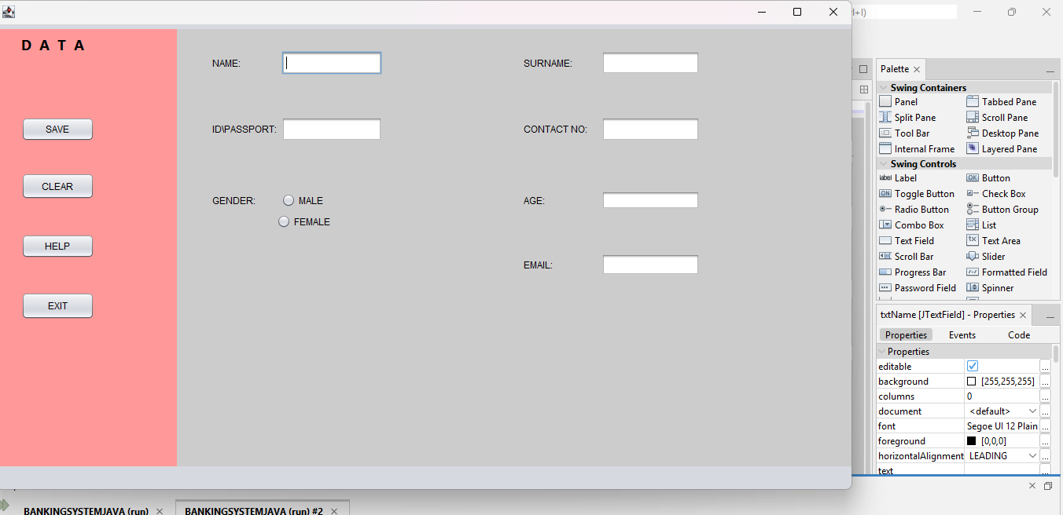

After Testing — Valid Input
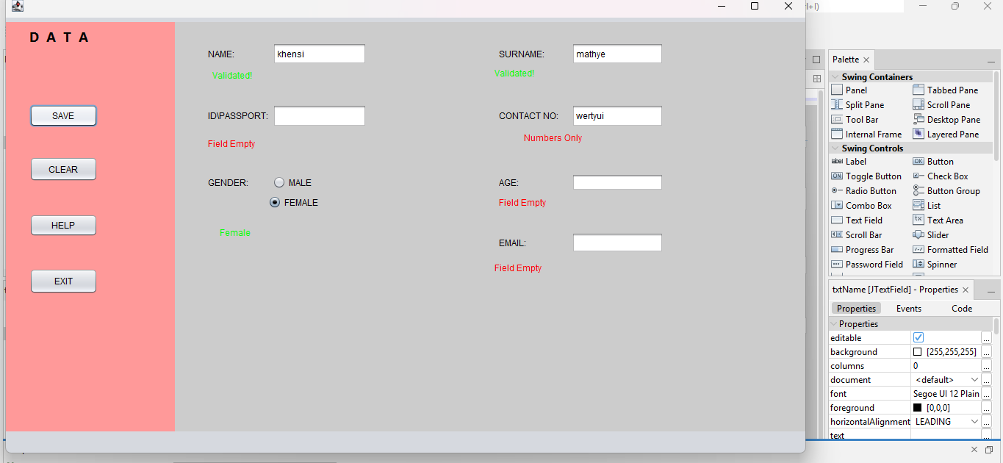

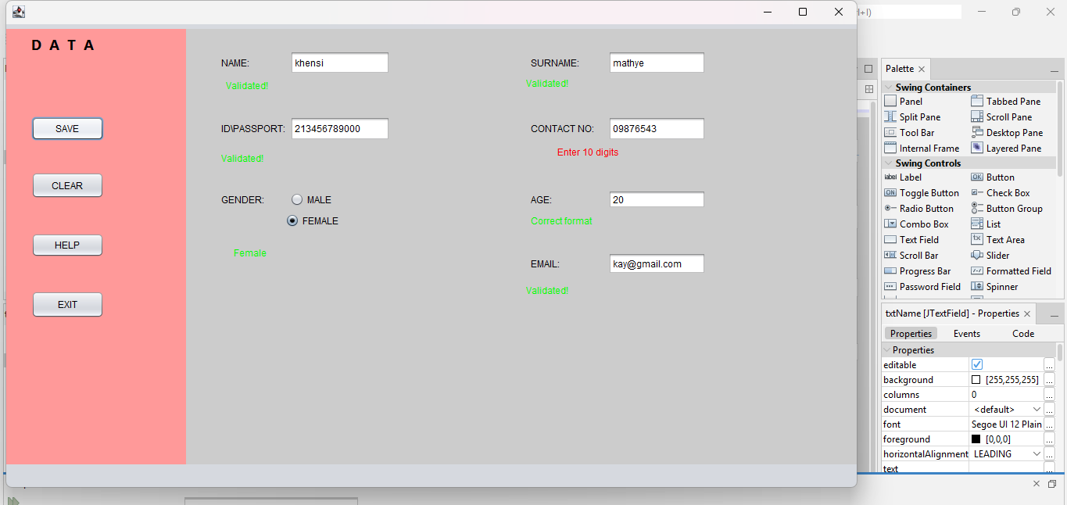

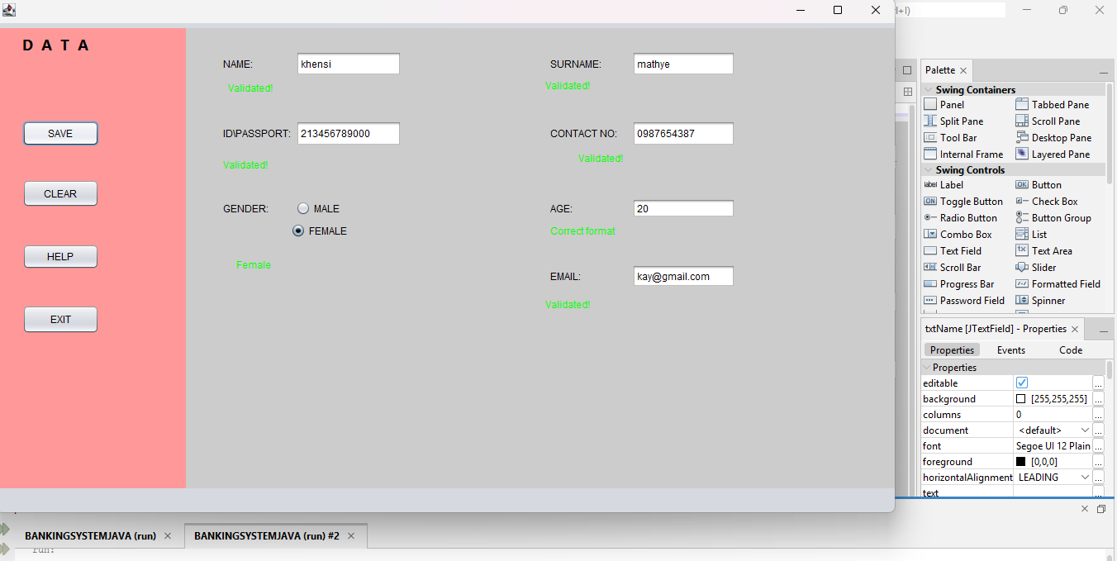

6. Code

Validation Conditions
if (name1.isEmpty()) {
name.setText("Field Empty");
name.setForeground(Color.RED);

}

else{
if (name1.matches("[a-zA-Z ]+")) {

name.setText("Validated!");
name.setForeground(Color.GREEN);
}

else {
name.setText("Letters Only");
name.setForeground(Color.RED);
}
Conditional statements are used to determine whether a field is empty or whether its value matches the required type, length, format or range. When a condition fails, the program displays a message telling the user what must be corrected.

Gender Selection
public datavalidation() {
initComponents();
ButtonGroup genderGroup=new ButtonGroup();
genderGroup.add(rdoMale);
genderGroup.add(rdoFemale);

The gender options are presented using radio buttons. The selected option is checked as part of the validation process so that the form does not accept the record when a required selection has not been made.

7. GitHub Repository
Khensie06/DATA-VALIDATION-SYSTEM

How to run the project:
A marker should clone or download the public repository, open the Java Swing project in the appropriate Java development environment, build the project and run the main JFrame class. The README.md should provide the exact project setup and run instructions.

8. Conclusion
Developing the Data Validation System provided practical experience in Java Swing, graphical user-interface design and input validation. The project required attention to how users enter information and how the application responds when information is incomplete or incorrectly formatted.
The main learning outcomes include using Swing components, handling button events, applying conditional validation logic, designing a user-friendly form and testing a program using both invalid and valid inputs. A further important part of the project was learning to document the development process and use GitHub to store and present the final project.

9. References
Oracle. (2024). Java Documentation. Available at: Oracle Java Documentation⁠
Oracle. (2024). Java Swing Documentation. Available at: Java Swing Documentation⁠
Apache NetBeans. (2024). Apache NetBeans Documentation. Available at: Apache NetBeans⁠

